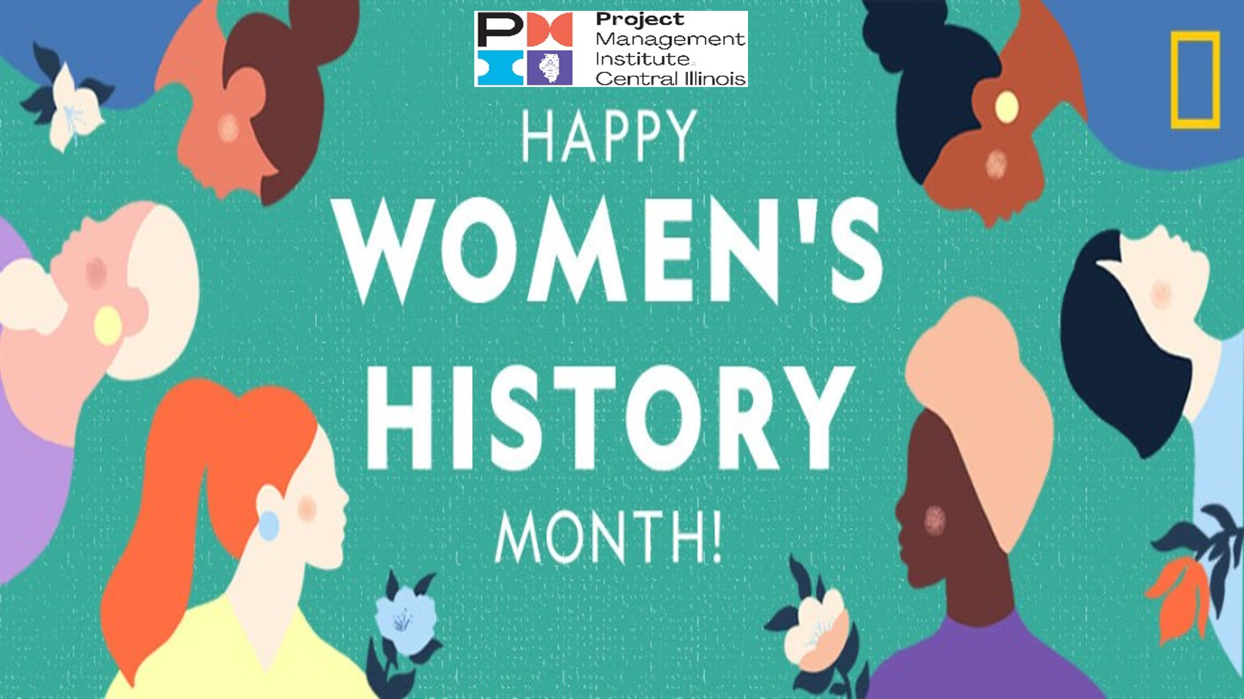

Women in Engineering and Project Management:
Still a Long Way to Go

Starting with some good news: the number of female project managers has increased 15% in the last ten years. Unfortunately, it only increased to 35%, according to Zippia. And more bad news, female project managers make 23% less than men.

This pattern of success and setbacks litters the history of women in engineering and project management. Ada Lovelace is credited with coming up with the first computer program in 1842. But until 1876, women who completed engineering studies were not allowed to receive the same diplomas as their male colleagues. Instead, they only received certificates of proficiency.

Before the first woman was ever awarded an official engineering diploma, Emily Warren Roebling served as the de facto Chief Engineer and project manager for the construction of the Brooklyn Bridge. From 1872, when her husband became bedridden, to 1883, when the bridge was open for use, she took on project management and day-to-day supervision of the bridge’s construction.

But it took the Second World War for engineering companies – shorthanded with so many men deployed to fight – to begin hiring women in significant numbers. Soon after, female “computers” were integral to the success of America’s space program. When the first machine computers came to NASA’s Jet Propulsion Laboratory in the 1950s, women became the first programmers.

Then, in the 1980s, companies began to market the first personal computers primarily by focusing on computer games – games that were marketed almost exclusively to boys. The percentage of women in computer science started to plummet, and it has yet to regain the peak it reached in 1985.

But there is a silver lining to the story. Since the 1969 founding of the Project Management Institute, women have been able to leverage their project management skills to gain positions of increasing authority.
Amazingly for its time, one of PMI’s five co-founders was a woman. Susan Gallagher of SmithKline & French Laboratories served as Treasurer, Vice President of Technical Services, and Director. She wanted to bring diverse people from every field of project management to learn, share, and advance the profession.

PMI’s history is replete with amazing women who furthered the profession. Regula Brunies joined in 1973, was PMI’s Person of the Year in 1982, and PMI’s First Female Chair in the 1980s. Joan Knutson began her own project management training consultancy in 1976. Rebecca Winston founded and co-chaired the Women in Project Management Specific Interest Group in the 1990s. Carol Wright started working as an associate programmer at IBM in 1978 and went on to establish the IBM Center of Excellence in 1998.

The Project Management Institute- Central Illinois Chapter continues this tradition of women’s achievement. While there is still a long way to go, PMI-CIC is proud to celebrate Women’s History Month, as we continue to work toward greater gender equity in project management and beyond.

Disclaimer: These statistics only look at gender binaries, and do not include trans individuals.

About the Author:
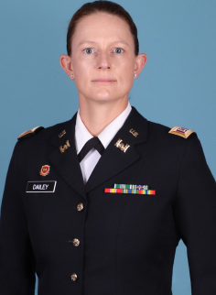
Ann Dailey, PMP, is a Captain in the United States Army. She currently is attending Engineer Captains Career Course in Fort Leonard Wood, Missouri. Prior to ECCC, she served as Aide-de-Camp to the Commander, Pacific Ocean Division, U.S. Army Corps of Engineers, and as an Executive Officer and Platoon Leader in the 25th Infantry Division in Hawaii. Prior to joining the Army, she worked as a Defense Department civilian with a focus on Russia and Eastern Europe. She has a Master of Arts in International Economics from the Johns Hopkins School of Advanced International Studies and a Bachelor of Arts from the University of Illinois. She was born and raised in Illinois. She is volunteering with the PMI-CIC chapter to develop her project management expertise and public engagement skills.

