Understand your team culture

Background
Culture can be understood as social beliefs, norms, behaviors that guide people to interact with each other in specific groups. Your team culture will decide how members collaborate with teammates to get work done. Understanding team culture is the key to help your team succeed and maintain high performance.

How to Understand
Based on Torben Rick’s iceberg model, corporate culture contains visible and invisible attributes. While visible attributes like vision, goals, procedures are easier to manage, invisible attributes like values, beliefs, shared assumptions really direct how people are working.
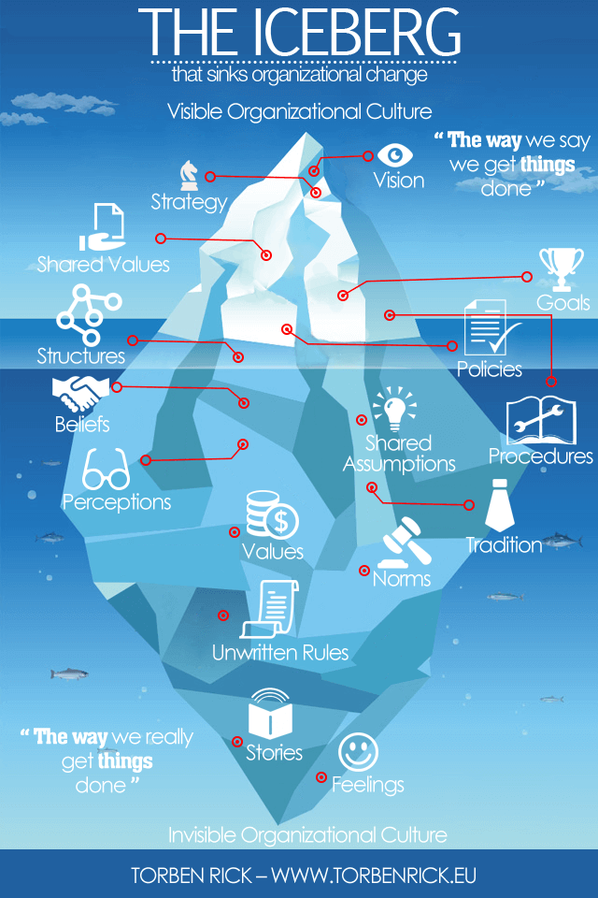
So, to understand team culture, we need to drill down to the bottom of the iceberg with people’s feelings, stories they tell to each other, ground rules about how people behave, team norms, and habits. From there, we see how things really get done; the way team members collaboratively interact with each other can interpret the team’s shared assumptions, what they believe, value to make decisions based on that. And it is a culture that defines the team’s beliefs, norms, and behaviors to guide day to day activities.
Let’s take an example of a small software team. We continuously define weekly team goals and follow some written processes, procedures to achieve the goals. They are what is easiest to see. The harder parts are how people feel and believe about the goals and ways to get them done. Do they engage and strongly trust the team as a whole will find its way to succeed? Do they follow the common values, principles to make day to day decisions like believing in people interactions over process and tools; working software over comprehensive documentation? If we can answer those questions, we understand how team members perceive the team goals and way of working. We also understand their norms and shared assumptions to achieve the common goals collaboratively.

How to Influence
When we are aware of both visible and invisible culture’s attributes, we can facilitate positive changes to help the team operate more effectively. The first action is empathizing with all team members to truly understand their feelings and motivations after each decision or behavior. Then, we get a feel on what they believe and value to see areas for improvement.
The way we introduce change, improvement should also target more to bottom of the iceberg and be a small thing at a time. Because real culture change cannot be fast after a series of meetings or guidance to everyone, it should be happening over a long period. Team members should be supported to grow independently, and leading should be done by examples to balance top-down and bottom-up driven.
And the most important thing should be empowering team members to build up their own healthy culture. Only the team members have the best understanding about their needs and feelings of teammates around them. They are in a better position to empathize with each others in daily activities. They together reinforce common team rules, norms and values. All of those invisible attributes drive people to reach the team goals or company vision in the long run.

Reference
Torben Rick, Organization culture is like an iceberg. Available at: https://www.torbenrick.eu/blog/culture/organizational-culture-is-like-an-iceberg/

