Ideal Structures for your Medium-Sized Team?

Context
When we start with a small Agile team, things are easy to communicate. People usually understand their teammates better, and they can quickly know who is doing what. It is also comfortable to gather the whole team and go through all of the work in progress. There is room for everyone to raise their concerns and seek advice from all members.
Things become tricky when the team’s size increases. With more communication channels, information can easily get lost, and gaps in knowledge occur, and misunderstandings emerge. This article is trying to help how we structure a medium-sized team (from 12 to 50 members)
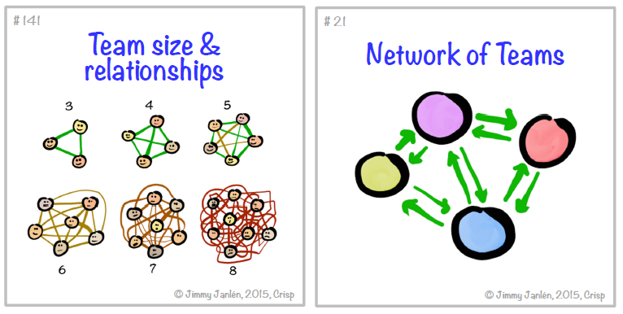

Problem refinement
What are the real pain points of a medium-sized team (comparing with a small agile team):
- Members might be overwhelming, with too many communication channels.
- Team meetings might take longer and ineffective, with less space for individuals to speak.
- Day-to-day activities require more overhead discussion, and information might still get lost.

Ideation
What are the potential actions to consider in this situation:
- Re-structure to component sub-teams.
- Re-structure to feature sub-teams.
- Re-structure to functional sub-teams.
- Keep the whole team but do differently with all meetings/ team events.
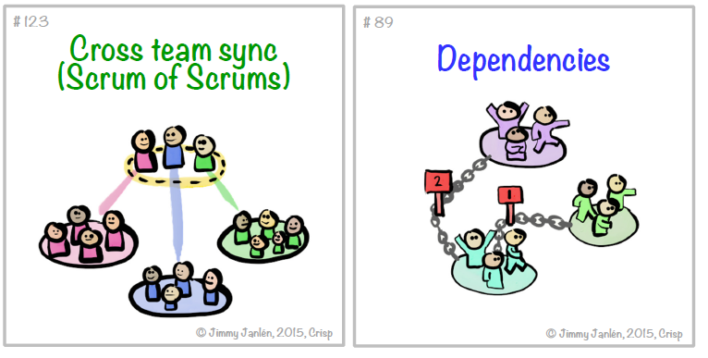

My journey
On one of my medium-sized teams with 20 members, we use the hybrid approach of those four basic strategies. We still keep the unit as one entity and mix with “sub-teams” based on product features, system components, and members’ specialties. This is not a clear split into “sub-teams,” but smaller groups focus on specific topics. It helps each member to have three particular channels to raise their voices with relevant teammates only. That minimizes overhead discussion and helps each member to stay focused on essential topics.
We only keep two events at the whole team level: Iteration Planning and Retrospective (organized back to back in half a day when transitioning from one iteration to another.). We hold the two meetings at the whole team level to allow people to start and end each Iteration with the big picture. Everyone should be aware of the Iteration goals before getting started. Then, people can make better decisions in day to day works to meet the Iteration goals. Later, the whole team retrospects the Iteration to decide what can be done differently (including the way we structure team).
During the iteration, we let people self-organize their work and proactively collaborate with “their sub-teams” for day-to-day activities. Besides, the Cross team sync with representatives of all sub-teams is an event to deal with dependencies and changes on the way. Representatives of sub-teams usually are leads or seniors of their specialties with sufficient knowledge about all components and features. They can make decisions based on the latest information on the way then communicate with their sub-teams more efficiently.

Conclusion
There is no ultimate answer to an ideal team structure. Consider the four basic strategies and construct a unique pattern that works for them. It should be based on actual needs and evolve through continuous experiments. Team structure can also grow to adapt to business needs and changes from the surrounding environment.

